**Update package manager:**

Install GIT

Initialize Git:

Git clone:

Install Docker:

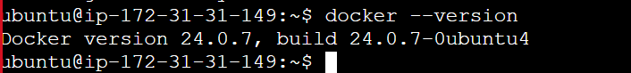



Docker file:

Install docker-compose:

**Docker compose file**

**Bash Scripting:**

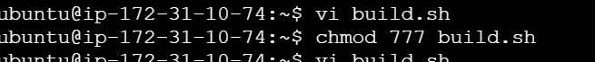

To build docker image:

To deploy docker image to server:

**Docker:**

Created prod repository and it is private.

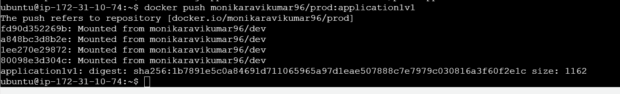

Created dev repo and it is public

**AWS:**

Launched EC2 instance.

Git:

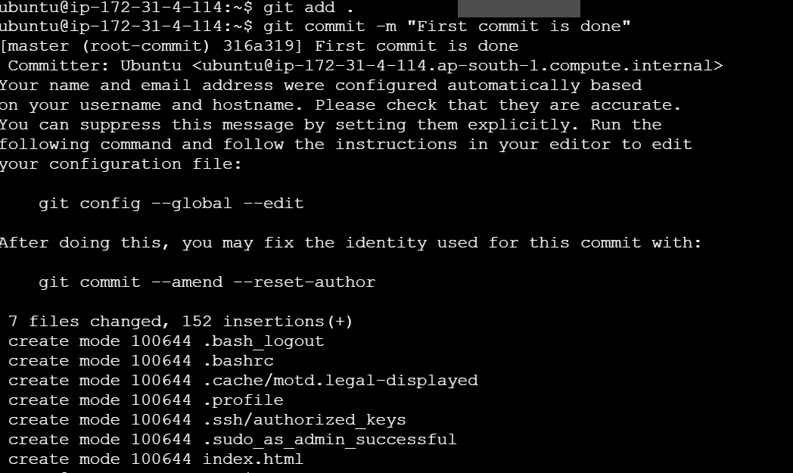

Jenkins:

Monitoring:

Install Grafana:

